Polynomial Regression - Complete Handbook

Definition
Polynomial Regression is a supervised learning regression algorithm used when the relationship between X and Y is non-linear. It fits a curved line instead of a straight line.

Category
Machine Learning > Supervised Learning > Regression

Use Cases
Sales Growth Forecasting
Population Growth
Demand Forecasting
Temperature Trends

Business Problem
Predict sales when growth is non-linear.

Formula
Y = b0 + b1X + b2X² + ... + bnXⁿ

Formula Naming
b0 = Intercept
b1,b2... = Polynomial Coefficients
X² = Squared Feature
Degree = Highest Power of X

Dataset
X | Y
1 | 2
2 | 5
3 | 10
4 | 17
5 | 26

Manual Calculation Concept
Polynomial Regression first creates extra features such as X², X³ etc. Then Linear Regression is applied on those transformed features.
X | X² | Y
1 | 1 | 2
2 | 4 | 5
3 | 9 | 10
4 | 16 | 17
5 | 25 | 26

Prediction Example
For X=6, equation approximately becomes Y = X² + 1
Y = 6² + 1 = 37

Graph Visualization
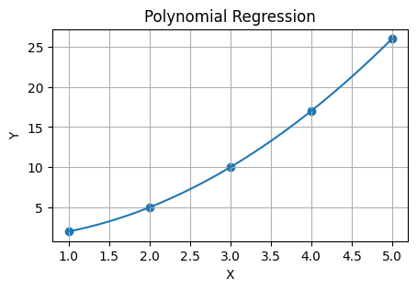

Python Implementation (Manual)
import numpy as np
X=np.array([1,2,3,4,5])
Y=np.array([2,5,10,17,26])
coef=np.polyfit(X,Y,2)
poly=np.poly1d(coef)
prediction=poly(6)
print(prediction)

Python Implementation (sklearn)
from sklearn.preprocessing import PolynomialFeatures
from sklearn.linear_model import LinearRegression
import numpy as np
X=np.array([[1],[2],[3],[4],[5]])
Y=np.array([2,5,10,17,26])
poly=PolynomialFeatures(degree=2)
X_poly=poly.fit_transform(X)
model=LinearRegression()
model.fit(X_poly,Y)
prediction=model.predict(poly.transform([[6]]))
print(prediction)

Interview Questions
1. What is Polynomial Regression?
2. Difference between Linear and Polynomial Regression?
3. What is Degree in Polynomial Regression?
4. When should Polynomial Regression be used?
5. What are the risks of high-degree polynomials?

Advantages
Captures non-linear relationships
Simple extension of Linear Regression

Limitations
Can overfit with high degree
Less interpretable than Linear Regression

